(Approx. 218 words)

Windows 8 Defender
By Rosita Herrick, Director, Sarasota PCUG, FL
November 2013 issue, PC Monitor
www.spcug.org
editor (at) spcug.org

I have been asked quite a few questions about virus and malware protection, so I thought I would spend some time to write about Microsoft’s security options in Windows 8. The Windows Defender is part of Windows 8 and comes with the installed system.

If you have another virus protection program like Norton, McAfee, AVG, AVAST etc., the Defender is not activated. While having one software package to protect you is good, two is not better. Matter of fact two active anti-virus programs can cause lots of trouble.

The quickest way to access the security options in Windows 8 is from the Search Charm.
Click on 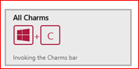to invoke the Charms bar.
Click on Settings and type Action in the search bar. This will be the result:

Now click on the Action Center box and you will be able to access both system security and system maintenance option. In order to view what you can do, click on the little arrow on the right side of the subject. If you want to make changes you will need to have Administrator privileges.
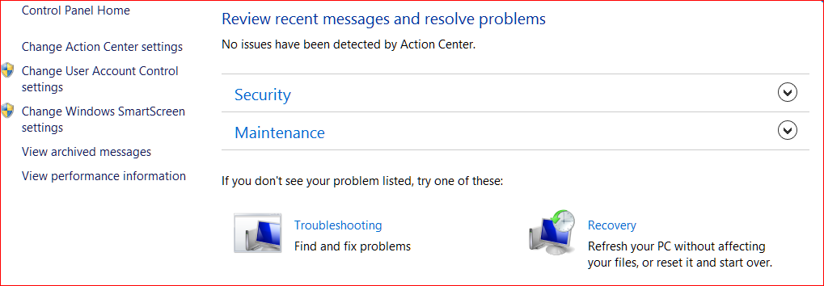

In summary, if you have no virus protection, activate Windows Defender. It is quiet, fast and will protect you from intrusions.

